Student Name: Meshaal Mouawad. Net ID: mm4922 Email: mm4922@msstate.edu SPRING 2021
Mississippi State University, Bagley College of Engineering, Electrical and Computer Engineering Department,
This is a weekly report of my research assignments I was given by Dr. Luo, who was advising me during my PhD program in 2021.
Weekly Report Milestone. WEEK.1
Voronoi Diagram Project March 21, 2021
Spring 2021
Summary of week 1 report.
The map was edited using Microsoft word which was the best software to get correct results the map created as shown in Fig. 5. and the results from MATLAB are Fig. 15, Fig. 16, and Fig.17. For map 3, the results are in Fig. 18, Fig. 19, and Fig 20.

MATLAB code for Voronoi Diagram project
1
The MATLAB code was given with 2 maps and the assignment was to change the default map included in the MATLAB with the map 1 and map 2 as it shows in fig.1 and fig. 2. I have prepared the images to be used in MATLAB programing environment by image editor in windows, but I could not run MATLAB code. I tried multiple technique to edited by Inkscape, but there were also some errors. I had to change the resolution in the code and the robotic radius. After that, I added border to map 1. As it shows in fig.3 and I run it again and I got MATLAB run it successfully!
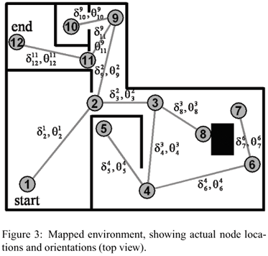
Fig. 1. The original map.1.
The figures produced by MATLAB had some issues in the Quadratic Form Graph as it shows in fig. 6. The path was not inside the map which I had to add boarder with changing the parameter of the resolution in the code and the robotic radius. After multiple changing, I created the map using Microsoft word by drawing table and take the advantages of the cells in the table as they are easily to adjust the dimensions which can be mathematically appropriate to navigate in MATLAB, therefore, I got the best results without changing the resolution and the robot radius as it shows is fig. 6.

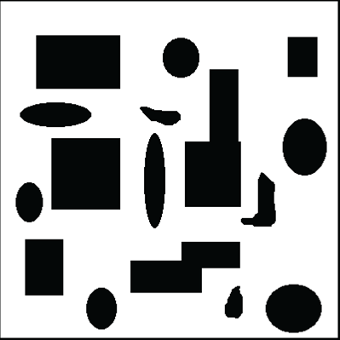
Fig. 2, The original map 2.
2
The map 2 was edited by image editor and the results were shown in Fig. 3 however, it shows some issued while producing the Quadratic Form Map and the Pixel Form Map. Even though it shows clean in the fig, but when MATLAB use it it shows some shadow of the old map which gives error. I use the same map in Inkscape with a library on GitHub and I created the map but I got also some errors which I realized that was the image quality using image editor was a problem, so I got to create new map on Inkscape. I run it but I got the results showing in Fig. 6 and Fig. 7. The results were not following the source point to the target that located inside the map. I added the boarder and I got also some incorrect path planning results.
I changed the robot radius and the resolution as the followings:
ROBOTRADIUS=3;
resolution = 1;

ROBOTRADIUS=1;
resolution = 0.2;

Using the InkScape with robot radius = 1, and resolution = 0.2 I got the results, but the maps generated were not good enough as shown in Fig. 11, Fig. 12, Fig. 13, and Fig 14 from MATLAB.
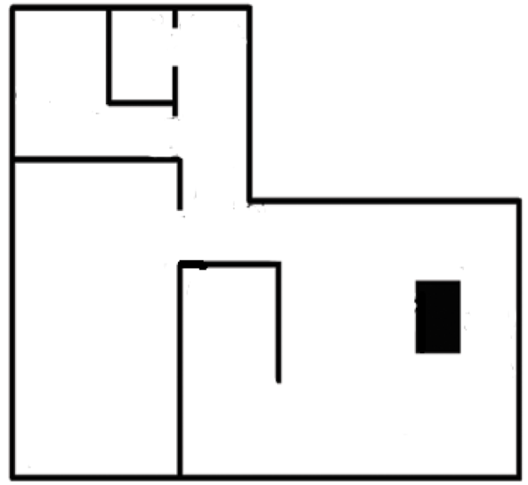
Fig. 3. The 1st edition of map 2 by removing the paths and cleared it using image editor which was not producing good results.
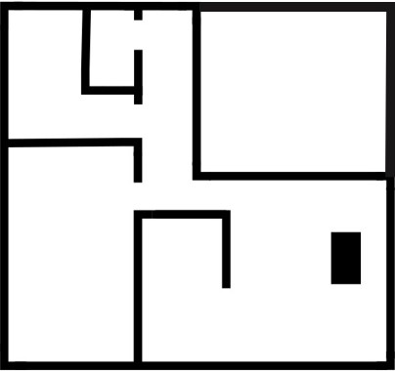
Fig. 4. The 2nd edition map 1 by using Inkskape which I added only some lines using the library from open sources.
3
The map 2 was created again using Microsoft Word as it shows in Fig. 5 (the 3rd edition). The results from MATLAB were the best results among all of them and there was no need to change the robot radius and the resolution, and I got the
best results among all of them without changing the radius and the resolution as it shows in Fig. 14, Fig. 15, and Fig. 16.

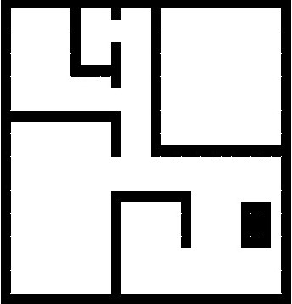
Fig. 5 the 3rd edition map 1 using tables from Microsoft Word
which shows reasonable results,
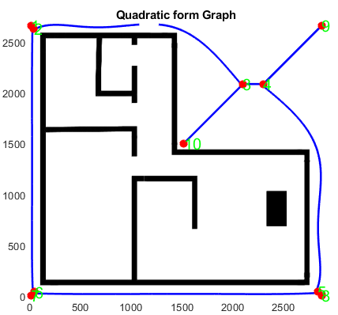
Fig. 6. Quadratic form graph error.
Fig. 7. Pixel form graph error.

Fig. 8. GVD from MATLAB
Fig. 9. Original map, complement, configuration free space, the GVD figures of the 1st edition map 2.
Fig. 10 map generated in MATLAB after adding the boarder which shows the paths are outside the map.
Fig. 11 the map generated from MATLAB after adjusting the image map, the radius, and the resolution.
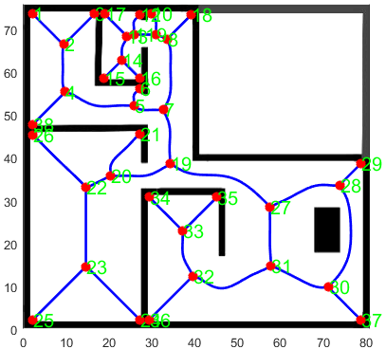
Fig. 12. Quadratic form graph for step 2 generated from matlab after adjusting the image map, the radius = 1, and the
resolution = 0.2.
4
Map 3 in Fig. 2 I run it without changing anything in the map image. I run it and test it for multiple robot radius and resolution and the results were almost same the same outputs here are the results from MATLAB in Fig. 17, Fig. 18, and Fig. 19.

Fig. 18. Map 2 results of the outputs from MATLAB.
Fig. 19. Map 2 GVD output from MATLAB.
Fig. 20. Map 2 results from MATLAB
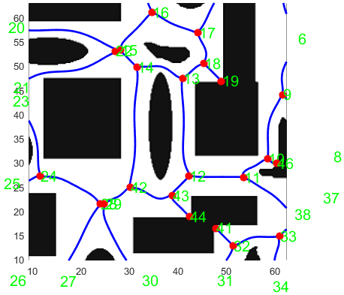
Fig. 21. Map 2, the Quadratic form map.
Fig. 21. Map 2, the pixel form graph.
Fig. 13. The GVD for step 2. With radius = 1, and resolution = 0.2.
Fig. 15. Step 3 map 2 results.
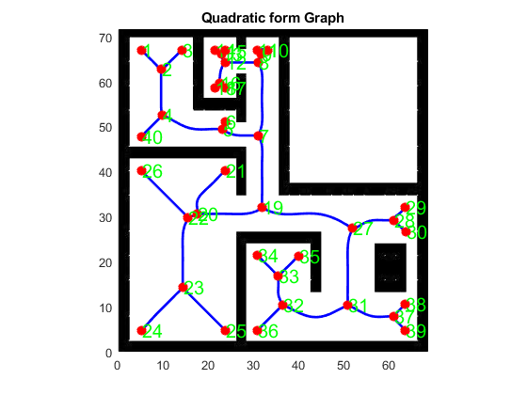
Fig. 16. Map 2 for step 2 with Microsoft word map edition.
Fig. 7. Pixel form map for step 3 with Microsoft word map edition.

Next Week Plan
1
Continue studying the concepts in the MATLAB code and master them.
2
How to set the start point (source) and the end point ( target) in MATLAB for the same map and the code.
3
How to identify the start point and the end point ( target) in the map in the same matlab code
4
Studying the easiest software to create the map using Inkscape, MATLAB, or Autocade.
5
Vector Field Histogram (VFH) and how to use it in SIMULINK.
6
Complete part 1 Classifying Images with Convolutional Networks, in Deep Learning with MATLAB course at MATLAB Academy.

Project/Assignment Suggestions
1
Adding different maps to the MATLAB code I saw some errors especially with robot radius and the resolution. I was thinking if the code can be improved to accept any map without changing the radius and the resolution. For example, if the code recognizes the edges and the obstacles whenever the map details changed the code can resize it appropriately to accept the same robotic radius and the resolution, then if not possible, the radius changed according to the map given to MATLAB.
2
Ho Using SIMULINK with code may add more features and flexible access as well a more realistic robotic environment ( I am so curious to learn SIMULINK with robots).
END

¹Meshaal Mouawad, Mississippi State University, Starkville, MS 39759 USA (e-mail: mm4922@msstate.edu).

